Some functions/libraries
1) LDA (Linear Discriminant Analysis), QDA (Quadratic Discriminant Analysis)
R package: MASS
function: lda, qda

2) KNN (k-nearest neighbor)
R package: class
function: knn

3) Bagging, boosting classification trees
R package: rpart, tree
function: rpart, tree
Our bagging/boosting programs are based on functions "rpart, tree" from these two packages.

4) SVM (Support Vector Machine)
R package: e1071
function: svm
The underlying C code is from libsvm

5) RF (Random forest)
R package: randomForest
function: randomForest
The underlying Fortran code is from Leo Breiman

6) Error estimation:
cv-10 (10-fold cross-validation); .632+
Package: ipred, which requires packages mlbench, survival, nnet, mvtnorm.
mvtnorm.ipred which provides very convenient wrappers to various statistical methods.

Download the relevant libraries as follows:
- click button “packages” on the R session bar
- choose “Install packages from cran..” Hint: the computer needs has to be connected to the internet.
- To find out the contents of a library, type help(package="ipred")
- read the libraries into the R session by using the library() command, see below.

R SESSION
library(MASS)
library(class)
library(rpart) # recursive partitioning, tree predictors....
library(tree)
library(e1071)
library(randomForest)
library(mlbench);library(survival); library(nnet); library(mvtnorm)
library(ipred)

# the followin function takes a table and computes the error rate.
# it assumes that the rows are predicted class outcomes while the #columns are observed #(test set) outcomes
rm(misclassification.rate)
misclassification.rate=function(tab){
num1=sum(diag(tab))
denom1=sum(tab)
signif(1-num1/denom1,3)
}

# Part 1: Simulated data set with 50 observations.
# set a random seed for reproducing results later, any integer
set.seed(123)
#Binary outcome, 25 observations are class 1, 25 are class 2
no.obs=50
# class outcome
y=rep(c(1,2),c(no.obs/2,no.obs/2))
# the following covariate contains a signal
x1=y+0.8*rnorm(no.obs)
# the remaining covariates contain noise (random permutations of x1)
x2=sample(x1)
x3=sample(x1)
x4=sample(x1)
x5=sample(x1)
dat1=data.frame(y,x1,x2,x3,x4,x5)
dim(dat1)
names(dat1)

# RPART (tree analysis)
rp1=rpart(factor(y)~x1+x2+x3+x4+x5,data=dat1)
plot(rp1)
text(rp1)
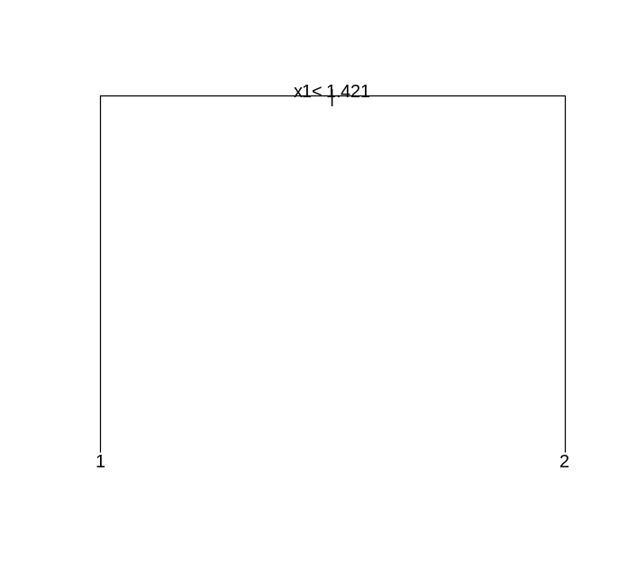
summary(rp1)
Call:
rpart(formula = factor(y) ~ x1 + x2 + x3 + x4 + x5, data = dat1)
n= 50
CP nsplit rel error xerror xstd
1 0.64 0 1.00 1.36 0.1319394
2 0.01 1 0.36 0.40 0.1131371

Node number 1: 50 observations, complexity param=0.64
predicted class=1 expected loss=0.5
class counts: 25 25
probabilities: 0.500 0.500
left son=2 (24 obs) right son=3 (26 obs)
Primary splits:
x1 < 1.421257 to the left, improve=10.2564100, (0 missing)
x4 < 2.640618 to the left, improve= 2.0764120, (0 missing)
x3 < 0.525794 to the left, improve= 0.7475083, (0 missing)
x2 < 1.686658 to the left, improve= 0.6493506, (0 missing)
x5 < 1.089018 to the right, improve= 0.4010695, (0 missing)
Surrogate splits:
x4 < 1.964868 to the left, agree=0.64, adj=0.250, (0 split)
x2 < 0.7332517 to the left, agree=0.60, adj=0.167, (0 split)
x5 < 0.820739 to the left, agree=0.58, adj=0.125, (0 split)
x3 < 0.7332517 to the left, agree=0.56, adj=0.083, (0 split)

Node number 2: 24 observations
predicted class=1 expected loss=0.1666667
class counts: 20 4
probabilities: 0.833 0.167

Node number 3: 26 observations
predicted class=2 expected loss=0.1923077
class counts: 5 21
probabilities: 0.192 0.808
# Let us now eliminate the signal variable!!!
# further we choose 3 fold cross-validation and a cost complexity parameter=0
rp1=rpart(factor(y)~x2+x3+x4+x5,control=rpart.control(xval=4, cp=0), data=dat1)
plot(rp1)
text(rp1)
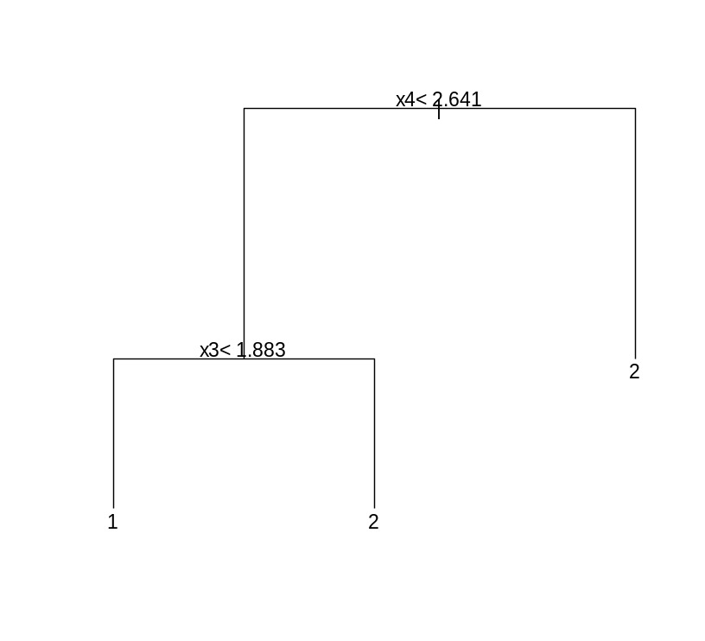
Note that the above tree overfits the data since x4 and x5 have nothing to do with y!
From the following output you can see that the cross-validated relative error rate is 1.28, i.e. it is worth than the naive predictor (stump tree), that assigns each observation the class 1.

summary(rp1)
- summary(rp1)
- Call:
- rpart(formula = factor(y) ~ x2 + x3 + x4 + x5, data = dat1, control = rpart.control(xval = 4,
- cp = 0))
- n= 50

- CP nsplit rel error xerror xstd
- 1 0.20 0 1.00 1.12 0.1403994
- 2 0.12 1 0.80 1.24 0.1372880
- 3 0.00 2 0.68 1.28 0.1357645

ETC

# let us cross-tabulate learning set predictions versus true learning set outcomes:
tab1=table(predict(rp1,newdata=dat1,type="class"),dat1$y)
tab1
1 2
1 18 10
2 7 15
misclassification.rate(tab1)
[1] 0.34

# Note the error rate is unrealistically low, given that the predictors have nothing to do
# with the outcome. This illustrates that the “resubstitution” error rate is biased.

#Let’s create a test set as follows
ytest=sample(1:2,100,replace=T)
x1test=ytest+0.8*rnorm(100)
dattest=data.frame(y=ytest, x1=sample(x1test), x2=sample(x1test),
x3=sample(x1test),x4=sample(x1test),x5=sample(x1test))

# Now let’s cross-tabulate the test set predictions with the test set outcomes:
tab1=table(predict(rp1,newdata=dattest,type="class"),dattest$y)
tab1

> tab1

1 2
1 34 26
2 20 20

misclassification.rate(tab1)
[1] 0.46

# this test set error rate is realistic given that the predictor contained no information.

#Linear Discriminant Analysis

dathelp=data.frame(x1,x2,x3,x4,x5)

lda1=lda(factor(y)~ . , data=dathelp ,CV=FALSE, method="moment")

> Call:
lda(factor(y) ~ ., data = dathelp, CV = FALSE, method = "moment")

Prior probabilities of groups:
1 2
0.5 0.5

Group means:
x1 x2 x3 x4 x5
1 0.9733358 1.474684 1.450246 1.405641 1.491884
2 2.0817099 1.580361 1.604800 1.649404 1.563162

Coefficients of linear discriminants:
LD1
x1 1.31534493
x2 0.12657254
x3 0.16943895
x4 0.06726993
x5 0.07174623

# resubstitution error
tab1=table(predict(lda1)$class,y)
tab1
misclassification.rate(tab1)
> tab1
y
1 2
1 19 6
2 6 19
> misclassification.rate(tab1)
[1] 0.24

### leave one out cross-validation analysis
lda1=lda(factor(y)~.,data=dathelp,CV=TRUE, method="moment")
tab1=table(lda1$class,y)
> tab1
y
1 2
1 18 7
2 7 18
> misclassification.rate(tab1)
[1] 0.28

# Chapter 2: The Iris Data

data(iris)
### parameter values setup
cv.k = 10 ## 10-fold cross-validation
B = 100 ## using 100 Bootstrap samples in .632+ error estimation
C.svm = 10 ## Cost parameters for svm, needs to be tuned for different datasets

#Linear Discriminant Analysis

ip.lda <- function(object, newdata) predict(object, newdata = newdata)$class
# 10 fold cross-validation
errorest(Species ~ ., data=iris, model=lda, estimator="cv",est.para=control.errorest(k=cv.k), predict=ip.lda)$err

[1] 0.02
# The above is the 10 fold cross validation error rate, which depends
# on how the observations are assigned to 10 random bins!
# Bootstrap error estimator .632+
errorest(Species ~ ., data=iris, model=lda, estimator="632plus",
est.para=control.errorest(nboot=B), predict=ip.lda)$err

[1] 0.02315164
# The above is the boostrap estimate of the error rate. Note that it is comparable to
# the cross-validation estimate of the error rate

#Quadratic Discriminant Analysis

ip.qda <- function(object, newdata) predict(object, newdata = newdata)$class
# 10 fold cross-validation
errorest(Species ~ ., data=iris, model=qda, estimator="cv", est.para=control.errorest(k=cv.k), predict=ip.qda)$err

[1] 0.02666667

# Bootstrap error estimator .632+
errorest(Species ~ ., data=iris, model=qda, estimator="632plus", est.para=control.errorest(nboot=B), predict=ip.qda)$err

[1] 0.02373598
# Note that both error rate estimates are higher in QDA than in LDA

#k-nearest neighbor predictors#
#Currently, there is an error in the underlying wrapper code for "knn" in package ipred. #The error is due to the name conflict of variable "k" used in the wrapper function #"ipredknn" and the original function "knn".
# We need to change variable "k" to something else (here "kk") to avoid conflict.

bwpredict.knn <- function(object, newdata) predict.ipredknn(object, newdata, type="class")
## 10 fold cross validation, 1 nearest neighbor
errorest(Species ~ ., data=iris, model=ipredknn, estimator="cv", est.para=control.errorest(k=cv.k), predict=bwpredict.knn, kk=1)$err

[1] 0.03333333
## 10 fold cross validation, 3 nearest neighbors
errorest(Species ~ ., data=iris, model=ipredknn, estimator="cv", est.para=control.errorest(k=cv.k), predict=bwpredict.knn, kk=3)$err

[1] 0.04

## .632+
errorest(Species ~ ., data=iris, model=ipredknn, estimator="632plus", est.para=control.errorest(nboot=B), predict=bwpredict.knn, kk=1)$err

[1] 0.04141241

errorest(Species ~ ., data=iris, model=ipredknn, estimator="632plus", est.para=control.errorest(nboot=B), predict=bwpredict.knn, kk=3)$err

[1] 0.03964991

# Note that the k=3 nearest neighbor predictor leads to lower error rates
# than the k=1 NN predictor.

# Random forest predictor
#out of bag error estimation
randomForest(Species ~ ., data=iris, mtry=2, ntree=B, keep.forest=FALSE)$err.rate[B]

[1] 0.04

## compare this to 10 fold cross-validation
errorest(Species ~ ., data=iris, model=randomForest, estimator = "cv", est.para=control.errorest(k=cv.k), ntree=B, mtry=2)$err

[1] 0.05333333

# bagging rpart trees
# Use function "bagging" in package "ipred" which calls "rpart" for classification.
## The error returned is out-of-bag estimation.
bag1=bagging(Species ~ ., data=iris, nbagg=B, control=rpart.control(minsplit=2, cp=0, xval=0), comb=NULL, coob=TRUE, ns=dim(iris)[1], keepX=TRUE)

> bag1
Bagging classification trees with 100 bootstrap replications

Call: bagging.data.frame(formula = Species ~ ., data = iris, nbagg = B,
control = rpart.control(minsplit = 2, cp = 0, xval = 0),
comb = NULL, coob = TRUE, ns = dim(iris)[1], keepX = TRUE)

Out-of-bag estimate of misclassification error: 0.06

# The following tables lists the out-of bag estimates versus observed species

table(predict(bag1),iris$Species)
setosa versicolor virginica
setosa 50 0 0
versicolor 0 46 5
virginica 0 4 45

# Note that the OOB error rate is 0.06=9/150

#support vector machine (SVM)
## 10 fold cross-validation, note the misclassification cost
errorest(Species ~ ., data=iris, model=svm, estimator="cv", est.para=control.errorest(k = cv.k), cost=C.svm)$error

[1] 0.03333333

## .632+
errorest(Species ~ ., data=iris, model=svm, estimator="632plus", est.para=control.errorest(nboot = B), cost=C.svm)$error

[1] 0.03428103

